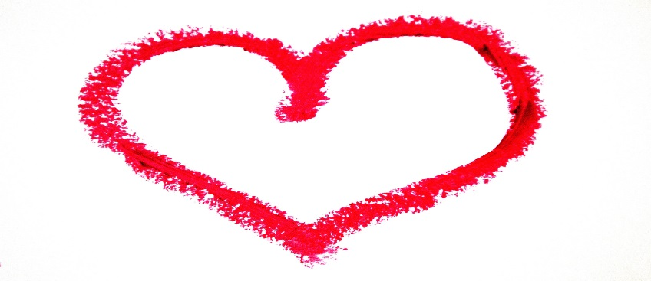
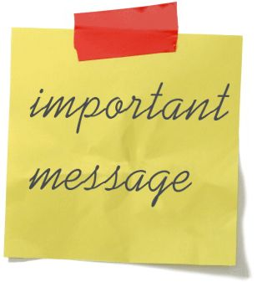 13 Reasons Why You Matter

#1 -- Every life is an important life.
Everyone has a purpose in life and though at times it may be hard to see, it does exist. You deserve to live your life the best you can.
#2 -- You are beautiful/handsome.
Despite what other people think or may tell you, you are beautiful/handsome. Beauty is in the eye of the beholder, so make the choice to see your beauty.
#3 -- You are unique.
There is no one on this earth like you. We are all different and that’s what makes us special. You cannot be replaced.
#4 -- You are smart.
Everyone is smart in their own way. There are things that you understand and know that other people might not get.
#5 -- We can learn from the pain we experience.
All the pain we experience in life can be used for the better. You can use that pain to push you and motivate you to do better.
#6 -- You are strong.
You have the strength to persevere. It may seem like life is too hard and you can’t keep going but you have an inner strength that can carry you through. It may not be easy but the fight is worth fighting.
#7 -- You are talented.
There are things that only you can do, whether you believe it or not. You have special skills and abilities.
#8 -- You can accomplish many things in your life.
You can do anything you set your mind to. So, focus on all the positive things you can do in your life. Set goals and achieve them. You have the courage and strength to do great things.

#9 -- You can make a difference in this world.
You can make a difference just by being you. You are valuable and have so much to offer this world. You have a voice that deserves to be heard.
#10 -- You can inspire others.
You have the ability to help others who are going through similar situations. You can turn a negative situation into a positive one.
#11 -- You have people who need you.
There are people in your life who need you just as much as you need them.
#12 -- You are never alone.
Even though it may feel like you are the only one on this earth and no one understands you or what you’re going through, it’s not true. People might not be in the same situation as you, but we all have feelings. We all have experienced the feeling of being hurt, left out or not good enough at some point in time.
#13 -- You. Are. Loved.
You are NOT unlovable. There are people who can see the goodness in you even when you can’t. You can and will be loved.

