Worriers to Warriors
Lindsey Jackson
Group Proposal Exercise
ED 577
Laura Samide

Introduction
The target population for Worriers to Warriors Group are Grades 1-5. The group will assist identified students that may be showing signs of anxiety or worry during the school day or at home. According to the Diagnostic and Statistical Manual of Mental Disorders, Version 5, Generalized Anxiety Disorder is defined as
“excessive anxiety and worry that occurs more often then not for a period greater than 6 months, the individual finds it difficult to control their worry, and the anxiety and worry are associated with three (or more) of the following six symptoms (with at least some symptoms having been present for more days than not for the past 6 months): Note: Only one item is required in children. 1. Restlessness or feeling keyed up or on edge. 2. Being easily fatigued. 3. Difficulty concentrating or mind going blank. 4. Irritability. 5. Muscle tension. 6. Sleep disturbance (difficulty falling or staying asleep, or restless, unsatisfying sleep)” https://doi.org/10.1176/appi.books.9780890425596.dsm05
The negative affects that anxiety and worry can have on a student can be both physical and/or mental. In can also cause impairments in social, occupational, and other important areas of functioning. When discussing anxiety and worry in young children it is possible to see greater risks if untreated or given the tools to combat their worries.
I would like the opportunity to evaluate and provide appropriate cultural context and social behavioral norms with these students. I believe that a group setting would best benefit those students that are exhibiting these behaviors, so they may also learn from each and gain understanding that they are not alone in the situation. The students will be able to better identify their feelings of worry and anxiety and learn some strategies on how to use it to their advantage. We will also identify safe and comfortable places where each student can feel relaxed and calm. I intend to teach real world applications that we will be able to practice together in the group situation. Potential hazards of this population would be compounding worry, giving them new ideas to worry about, and/or risk a confidentiality breach. The potential benefits seek to help students develop better coping strategies, build relationships with others with similar struggles, have a place to practice the strategies they learn, and overall too help decrease their worry or anxiety. Below I will outline our course of action, pre and post screenings, lesson plans, and objectives.

Group Name: Worriers to Warriors (Outside of group we are referenced as the Warrior’s group)
Length: 6 weeks, 30-40 min. sessions
Target: Grades 1-5
Objectives:
- To assist students with a better understanding that they are not alone in terms of their worries and anxiety.
- To assist students to a better understanding that their worries and anxiety may be useful, but may also interfere with their goals, fun, and happiness.
- To assist students to better recognize situations and circumstances that make them feel relaxed, safe, and comfortable
- To assist students to better recognize situations and circumstances that make them feel nervous, anxious, or worried.
- To assist students in gaining knowledge, exploring strategies, practice coping mechanics in hopes to decrease their anxieties and worries.

Group Leadership:
Leader: School Counselor
Selection: Recommendation by teachers or families
Preparation:
- Letter for family members with consent form. Make sure you have consent before the start of group
- Pre-Test – before group meets send home a copy of pre-test with student
- Post-Test – at the end of group have student’s fill out at their last session (exit ticket)
- Group evaluation
- Leader evaluation
- Materials list – Worry Scale (one for each group member), Construction Paper (assorted colors), Markers, crayons, pencils, colored pencils, the book ISH, the book Wemberly Worried, Worry Free Me! Booklet (one for each group member), When I get worried or nervous, this is where I feel it in my body worksheet (one copy for each group member), A Froggy Fable book, glue sticks, Inner and outer circles copied on card stock (one for each group member), paper fasteners, plastic cap from a milk or OJ carton, scissors, one calming stone for each student, one copy of Worry Scale for each student.

Small Group Lesson Plan

Small Group Counseling Title/Theme: Worriers to Warriors

Session Title: Get Acquainted Session # 1

Grade Level: 1-5 Estimated time: 30 minutes

Small Group Counseling Session Objective:
- To provide an opportunity for students to become acquainted with one another.
- To provide an opportunity for students to develop trust with one another, including the counselor.
Indiana School Counseling Competencies for Students:
- The student identifies emotions within varying contexts.
- The student identifies respectful behavior towards self and others.
- The student describes ways in which students can support those who are bullied or experiencing personal challenges, including reporting mechanisms.
ASCA Mindsets/Behaviors:

- Sense of belonging in the school environment
- Positive attitude toward work and learning

Materials/Supplies Needed (include activity sheets and/ or supporting resources)
- Copy of worry scale for each student
- 1 piece of large white construction paper for each student
- Markers, crayons, and/or colored pencils
- The book ISH by Peter H. Reynolds

Assessment Strategy (How will you show outcomes of your group counseling intervention? What data are you collecting?)
Completed Worry Scale – for my records only, will assess where their level of worry is at. This will not go home with student.

Preparation:
- Introductions
- Explain group
- Explain group rules
Essential Question: “I worry this much”

Engagement Question/Hook/Icebreaker:
“Worry Scale” and personalize their folders

Procedures
School Counselor Procedures/Steps  - Introductions  - Explain group  - Explain group rules  - Have students complete the “Worry Scale”. Depending on the grade level, you’ll probably have to read the instructions and explain to students how to complete the form. This “Worry Scale” will act as a pre-test. Be sure to have students date the form. Encourage students to work on their own, independently, according to what they think and feel about their own worrying.  - Collect forms (keep separate from the materials students will take home)  - Members will personalize their folders for use to store their group materials between meetings. Make folders our of large white construction paper. Have them decorate their folder by drawing a picture of one of their favorite places – a peaceful place where they feel relaxed, comfortable, calm, and happy.  - Read the book ISH by Peter H. Reynolds while students decorate folders.  - Have student share their picture if they want to  - Collect folders at the end of group and store until next meeting.  - Close the group by using a musical instrument and choosing one group member to create a musical pattern with it. After they create one, all other group member will replicate the pattern. | Student Involvement (anticipated/expected)  - Student’s will introduce themselves to the group.  - Student’s will decide on group norms.  - Student’s will complete the pre-test.  - Student’s will personalize their group folder.  - Student’s will listen to storybook.  - Student’s will share their drawings if they feel they want to.  - Student’s will close group playing a musical pattern.

Follow-Up Activities:
None

Counselor reflection notes:
STUDENT LEARNING: How will students’ lives improve as a result of what happened during this session?
Student will remember their happy places. Student’s will understand group format and norms.

SELF EVALUATION: How did I do? What could I do differently to improve the lesson? What were the strengths of the lesson?
Make an example of a folder with my happy place on it to show students.

IMPLEMENTATION PROCEDURES: How did the session work?

Small Group Lesson Plan

Small Group Counseling Title/Theme: Worriers to Warriors

Session Title: You Are Not Alone Session # 2

Grade Level: Grades 1-5 Estimated time: 30 minutes

Small Group Counseling Session Objective:
- To help students realize that worrying and feeling anxious and nervous are parts of our everyday lives.
- To provide an opportunity for students to share some of their worries, anxieties and fears.
Indiana School Counseling Competencies for Students:
- Student identifies problem solving skills and can use words to discuss possible solutions.
- Student identifies situations that cause anxiety and strategies to channel such worry into socially responsible choices.
- Student identifies situations that cause stress and strategies to reduce stress.

ASCA Mindsets/Behaviors:

B-SMS 5. Demonstrate perseverance to achieve long- and short-term goal
B-SS 2. Create positive and supportive relationships with other students
B-SS 3 Create relationships with adults that support success.
B-SS 4 Demonstrate empathy
Materials/Supplies Needed (include activity sheets and/ or supporting resources)
Book Wemberly Worried by Kevin Henkes
One copy of the “Worry Free Me!” booklet for each student
Pencil for each student

Assessment Strategy (How will you show outcomes of your group counseling intervention? What data are you collecting?)
Reviewing student responses will show if the students are following lesson.

Preparation:
- Have booklets premade
- Coping strategies prepared
Essential Question:
- When do YOU worry?
Engagement Question/Hook/Icebreaker:
- When do people usually worry?

Procedures
School Counselor Procedures/Steps  - Confidentiality  - Group Norms  - Brief check-in  - Explain that everybody worries – it’s a natural part of life. Aske “When do people usually worry?” Write down student’s responses on a white board or poster board.  - Read and briefly discuss the book Wemberly Worried by Kevin Henkes.  - “When do YOU worry?”: Complete first two parts of the “Worry Free Me!” booklet pages. Share with group if there is time. Have students put their booklets in their folders.  - Close the group with a musical patter chosen by the child who is the leader that day. | Student Involvement (anticipated/expected)  - Student will discuss their worry over the past week.  - Student will think of ways everyone worries.  - Student will write down two ways they worry and strategies to help.  - Student will play musical pattern on instrument.

Follow-Up Activities
Check in with students through out the week.

Counselor reflection notes (completed after the session)

STUDENT LEARNING: How will students’ lives improve as a result of what happened during this session?
Student will be able to come up with strategies to help their individual worries.

SELF EVALUATION: How did I do? What could I do differently to improve the lesson? What were the strengths of the lesson?

IMPLEMENTATION PROCEDURES: How did the session work?

Small Group Lesson Plan

Small Group Counseling Title/Theme: Worriers to Warriors

Session Title: Taking a closer look at Worry and Anxiety Session # 3

Grade Level: Grades 1-5 Estimated time: 30 minutes

Small Group Counseling Session Objective:
- To help students develop an awareness of how worry and anxiety can feel in their bodies.
- To help students develop and increased awareness that some worry and anxiety can be helpful to us in our lives.
- To help students develop an understanding that worry and anxiety can get in the way of our goals and happiness, and when it does, it becomes a problem.

Materials/Supplies Needed (include activity sheets and/ or supporting resources)
- One copy of the “When I get worried or nervous, this is where I feel it in my body” worksheet for each student.
- Markers
- A Froggy Gable by John Lechner

Assessment Strategy (How will you show outcomes of your group counseling intervention? What data are you collecting?)
Notice whether or not the student can express where they feel the worry in their body.

Preparation:
- Complete body worksheet
Essential Question:
- Where do we feel worry, nervousness and anxiety in our bodies?
Engagement Question/Hook/Icebreaker:
- Where do we feel worry, nervousness and anxiety in our bodies?

Procedures
School Counselor Procedures/Steps  - Brief check in  - “Where do we feel worry, nervousness and anxiety in our bodies?” Have students complete body worksheet.  - “How does worry sometimes help us?” Write down student brainstorm responses on white board.  - “How do worries get in our way? When does worry and fear become a problem for us?” Write down student responses. Add any if necessary.  - Explain that everyone worries, but some people worry more than others – and for those people, worrying can get in the way of their learning and happiness. That is why we must figure out strategies to help make the worry smaller.  - Read and discuss A Froggy Fable by John Lechner.  - Close the group with a musical patter chosen by the child who is the leader that day. | Student Involvement (anticipated/expected)  1. Students listen and respond/ask clarifying questions.

Follow-Up Activities DO NOT NEED FOR 20-MINUTE PSCYHOEDUCATIONAL LESSON

Check-in with students to see how their new strategy is working for them.

Counselor reflection notes (completed after the session) DO NOT NEED FOR 20-MINUTE PSCYHOEDUCATIONAL LESSON

STUDENT LEARNING: Student can identify how their body feels when anxious or worried.

SELF EVALUATION: How did I do? What could I do differently to improve the lesson? What were the strengths of the lesson?

IMPLEMENTATION PROCEDURES: How did the session work?

Session #4: Strategies
Objectives:
- To help students identify strategies for coping with worries and anxieties.
- To help students learn new strategies for coping with worries and anxieties.
Materials:
- Materials for each student to make a Channel Changer:
  - Copies of the outer and inner circles copied onto cardstock – best if the outer and inner wheels are two different circles
  - One paper fastener for each student
  - One plastic cap from a milk or OJ carton
  - Colored pencils
  - One pair of scissors for each student
  - Glue
Activities:
- Brief check-in.
- Today we’re going to talk about strategies for helping to make our worries, fears and nervousness get smaller. “What are some strategies that have worked for you in the past, to help you not worry as much?” Write down student responses on a white board.
- Have students get the “Worry Free Me!” booklets out. “Let’s look at some of the worries you wrote in your booklet. What are some strategies that might help each person with each worry?” Write down responses on white board.
- Other strategies:
  - Self-talk – be your own helper. “What can you tell yourself when you are afraid, nervous or worried?”
  - Relaxation and Visualization
  - When you are “stuck” in a worry thought – change the channel! Try to think of something else. Have each student create a “Channel Changer”.
  - Talk about it – ask for help from a grown-up. Brainstorm support people.
- Close the group with a musical patter chosen by the child who is the leader that day.

Session #5: Finding the Strategy That Works
Objectives:
- To help students identify strategies that might work to alleviate their particular worries and anxieties.
- To provide an opportunity for students to practice the strategies they selected.
Activities:
- Brief check-in
- Have students complete third part of their “Worry Free Me!” booklet.
- Share booklets
- Practice some of the strategies they chose for each “worry” or fear.
- Close the group with a musical pattern chosen by the child who is the leader that day.

Session #6 – Celebrating Our Success
Objectives:
- To help students realize that we all have worries, but they know strategies to prevent those worries from getting in the way of their happiness and fun.
- To reinforce knowledge learned by students during the past five sessions.
- To help students feel empowered by developing a program (Worriers to Warriors) to help other kids learn about strategies for coping with worry.
- To provide students with a memento that will remind them of their strength and strategies.
Materials:
- One calming stone for each student
- One copy of the “Worry Scale” (“I worry this much” sheet) for each student.
Activities:
- Brief check-in
- Reflecting on what we learned – “What have you learned that you think will help you most?”
- Possibly create a puppet show that might help other kids not worry as much, based on what they learned during the past five weeks.
- Calming stones – give each student a special “calming stone” to remind him/her of his strength, and to remember to stay calm and use the strategies learned to help them in the future.
- Have each student complete a copy of the “Worry Scale” again – this will act as a post-test. Have them be sure to date it. Do not give them the first copy of the Worry Scale they completed during the first group. Collect the post-test “Worry Scale” – keep for your info/records.
- Close the group with a musical instrument patter chosen by the child who is the leader that day. Students will leave with the folders they created during the first group, which will contain their “Channel Changer”, “Worry Free Me!” booklets, and “This is where I feel worry…” sheet.

Dear Parent or Guardian,

In today’s society, students are faced with more challenges than ever before; the goal of the counseling department at Carroll Elementary School is to help students overcome the many adversities they face and to help students reach their full potential as they transition into adulthood. To make this goal a reality, we offer a variety of small counseling groups throughout the school year. We would like to take this opportunity to invite your child, ___________________________, to participate in a small- group experience on worry. This group, Worriers to Warriors, will focus on teaching strategies to help students build resiliency, manage stressors, and to utilize their inner strengths. We hope that students will leave the group better able to combat life’s challenges, using the knowledge and skills they will have acquired from their participation. The group will meet for six sessions, once a week, for 30 minutes, during the school day. Meeting times will rotate to avoid missing the same class repeatedly. Students are expected to make up any missed work and will be fully supported by their teachers in doing so. A schedule of group times will be sent home with your student once consent is given. We hope to build a trusting relationship with your student. In order to ensure this trust, all information shared within the group will be kept confidential unless there is an ethical responsibility to break confidentiality. If you have any further questions, we can be reached at Carroll Elementary School between the hours of 8AM and 5PM at 574-967-4882. If you find you are unable to reach us during these hours, please feel free to leave a message and your call will be returned promptly.
Sincerely,
Lindsey Jackson
School Counselor
Please sign and return the permission slip below by September 3, 2018 if you DO NOT want your student participating in the group. I DO NOT give permission for my student, ___________________ to participate in the Worriers to Warriors Group
Print Student’s Full Name ___________________________
Parent/Guardian Name Parent/ Guardian Signature ___________________________
*Consent form original from Coping Skills SWAG group curriculum
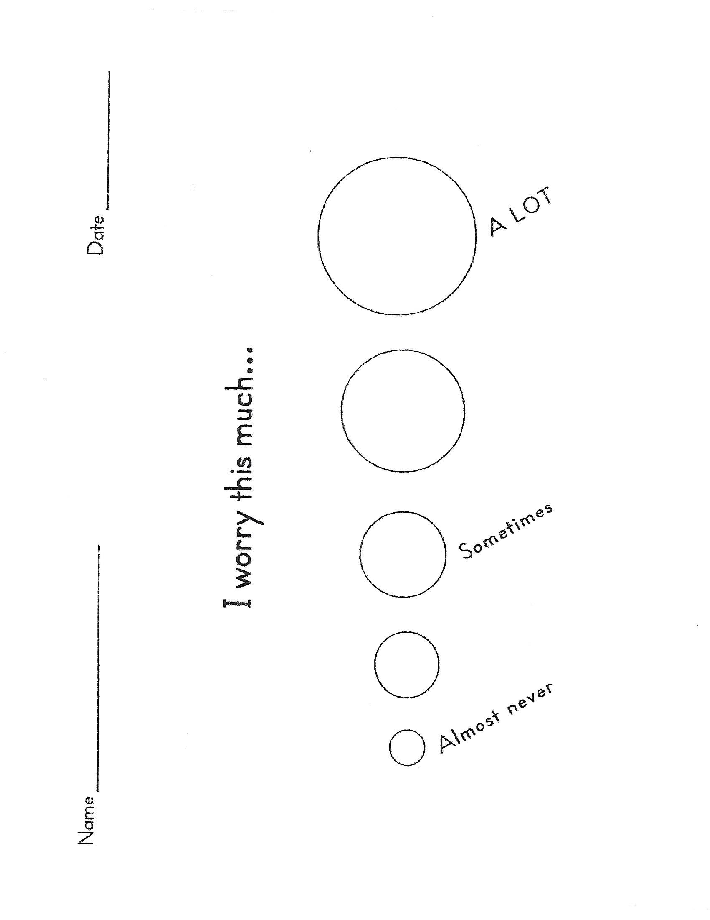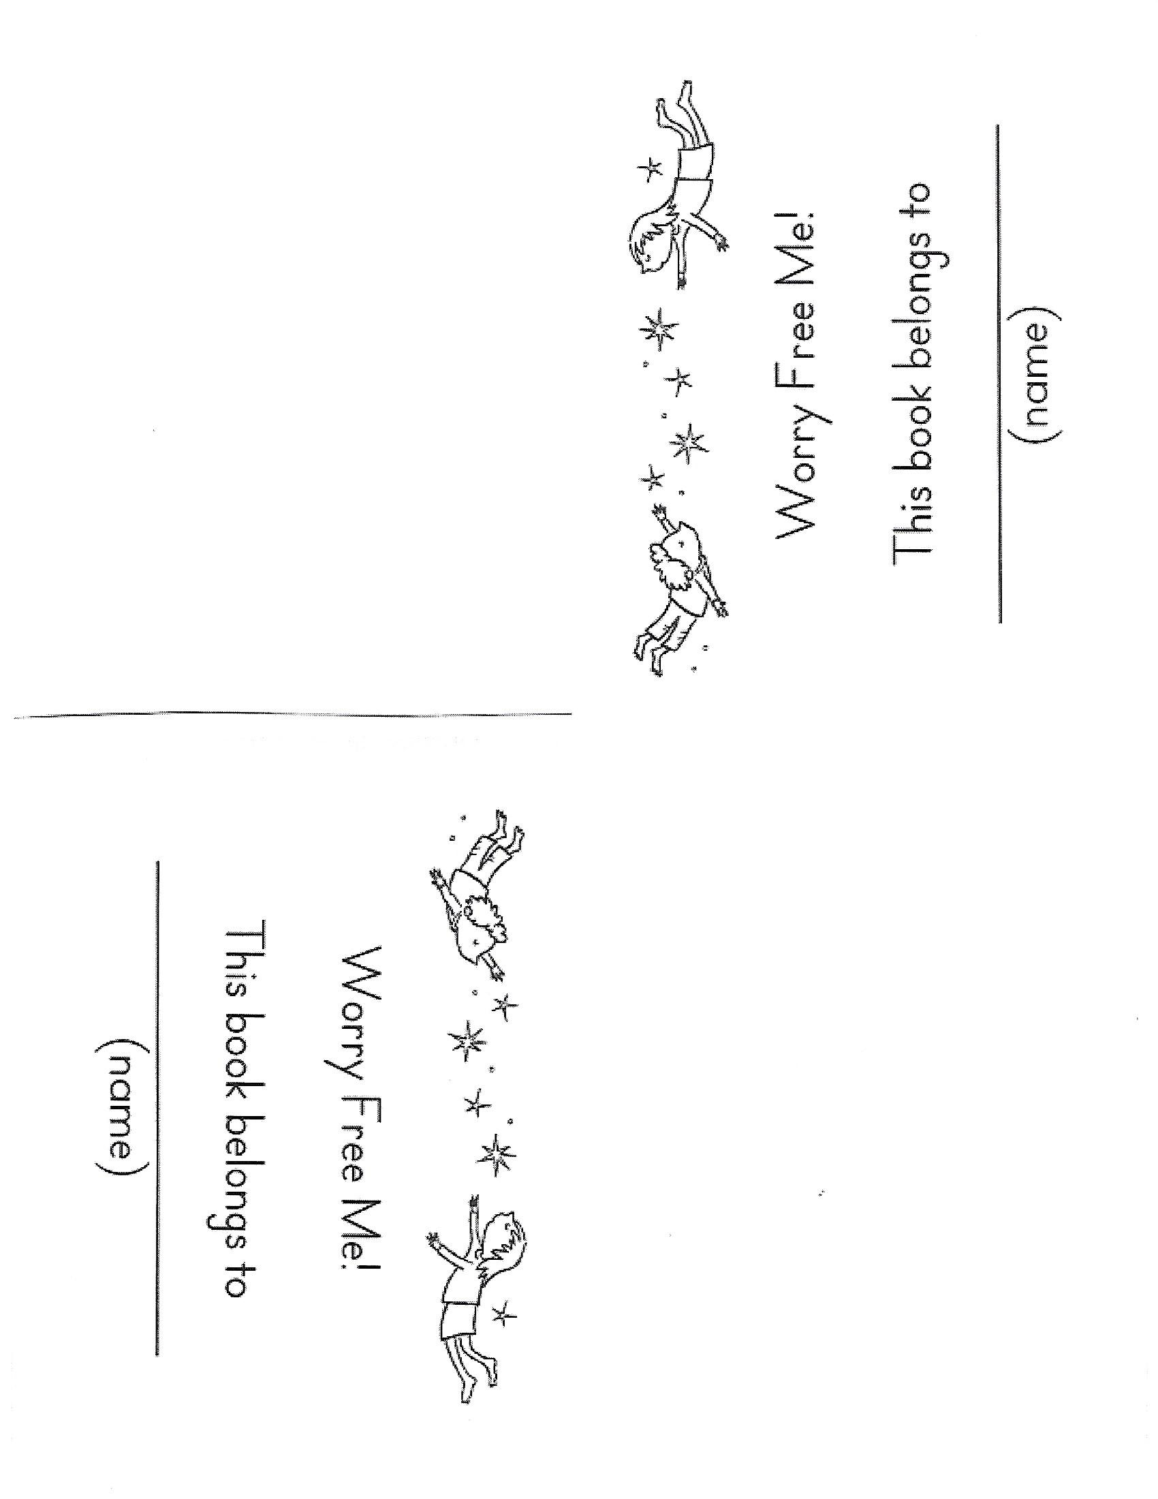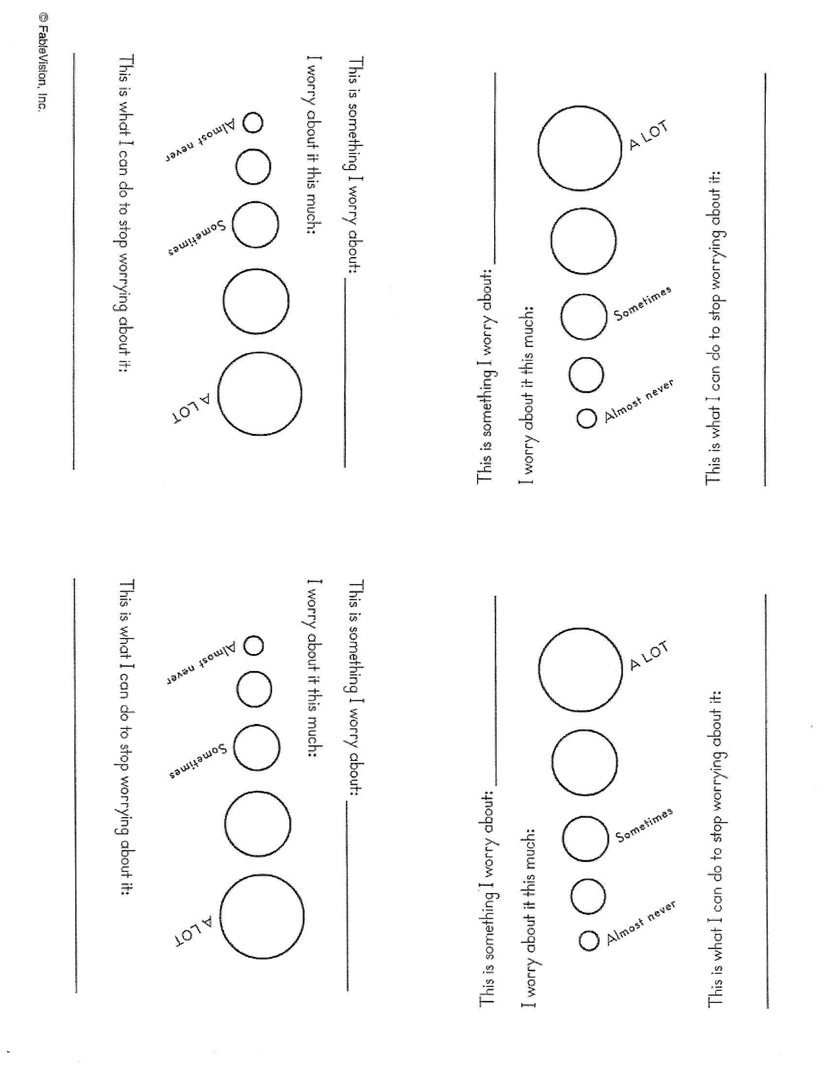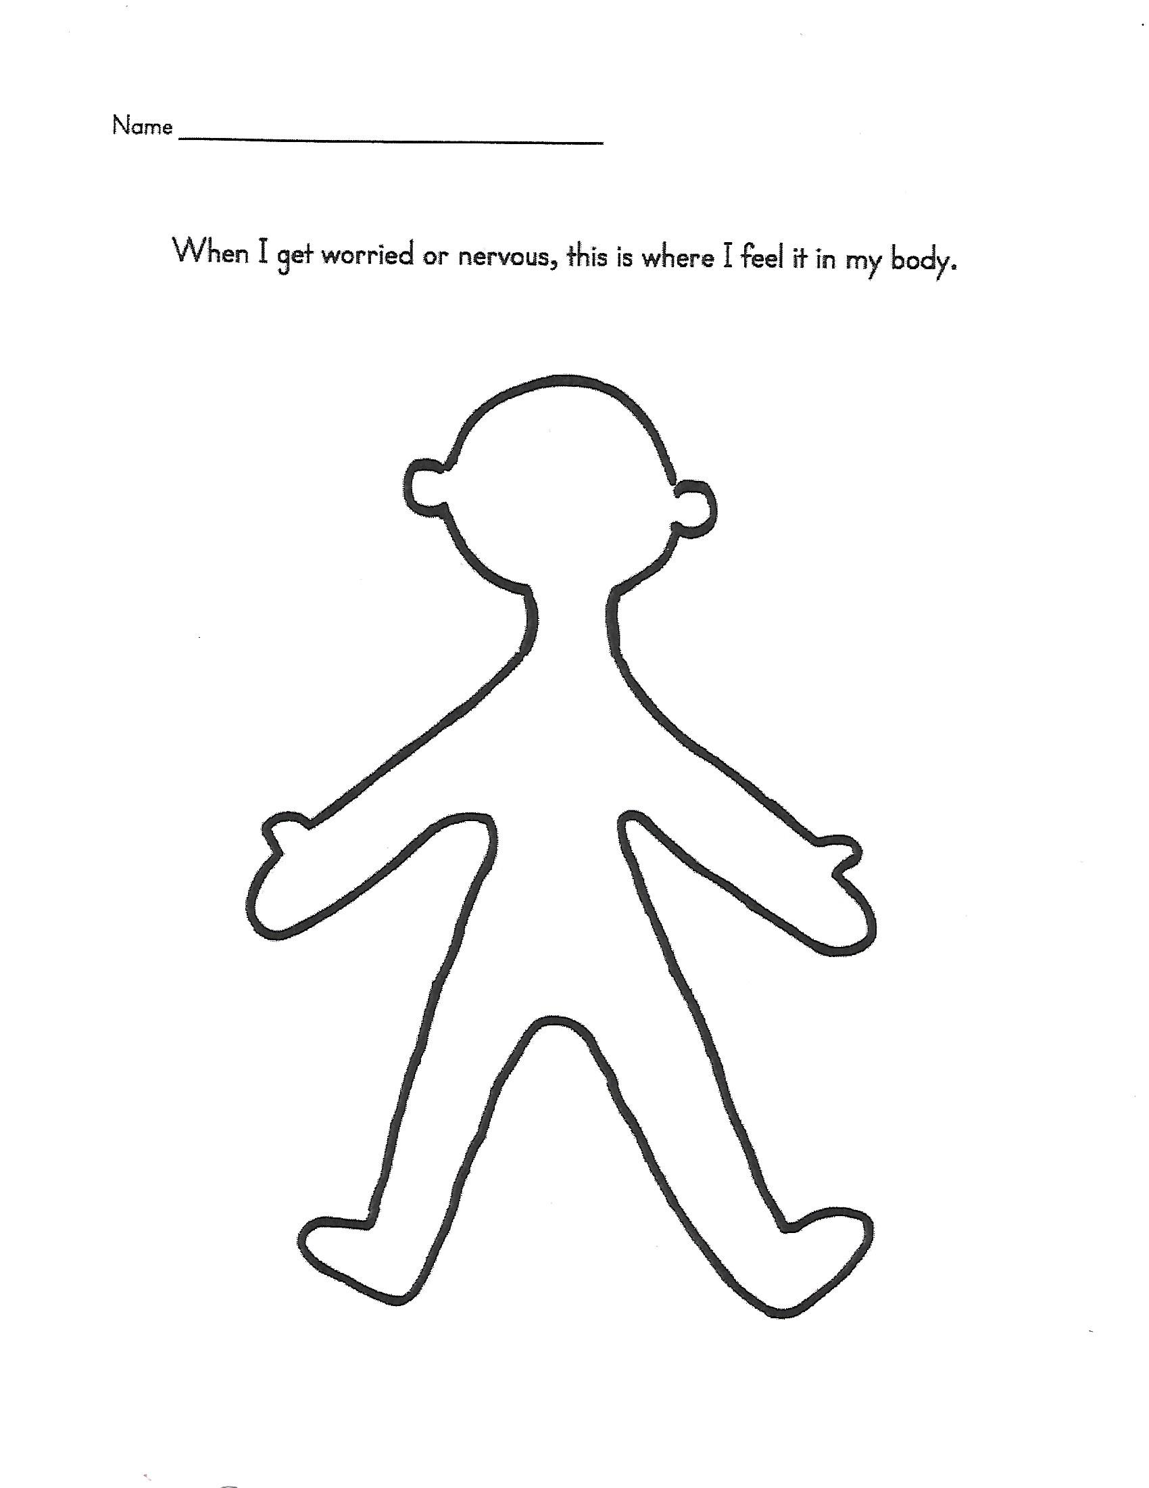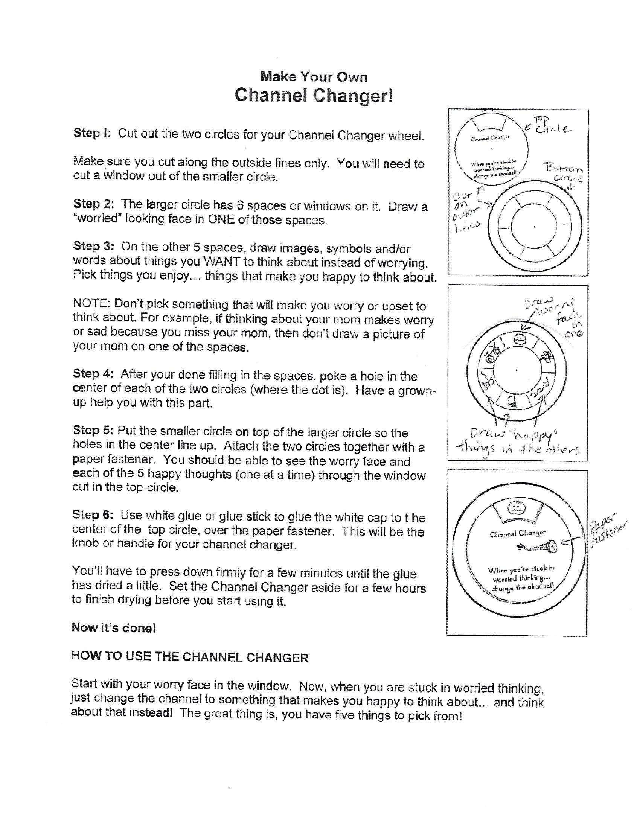
References

Bush, M. M.S., N.C.C. (2005) “Relaxing with Friends” small group curriculum for Grades 1-5. Files from office at Carroll Elementary School 2018.

Garrorvillo, N. Rodriquez, J., Smith, L. “Students With A Gift” A coping skills group for 6th – 8th grade at risk students. Access granted by Laura Samide for purpose of graduate studies.

Kottler, J.A., Englar-Carlson, M. (2015) Learning Group Leadership, An experiential Approach. Third Edition.

