G.C.Y.E.

Getting Comfortable with Your Emotions:

An Emotional Health Program for 6th-8th grade Boys
Alicia Justice

Table of Contents:
Introduction………………………………………………………………………………………………………….3
Method………………………………………………………………………………………………………………….4
Sessions………………………………………………………………………………………………………………...5
1: G.C.Y.: Setting the Foundation………………………………………………………………... 5-8
2. G.C.Y: Popcorn Emotions………………………………………………………………………...9-13
3. G.C.Y: Guys & Girls: Mars vs Venus……………………………………………...………..14-17
4. G.C.Y: Beneath the Surface: Your Emotional Iceberg…...………………………..18-21
5. G.C.Y:Emotional Expression: Behind the Mask………………………………………22-25
6. G.C.Y: Ending Well: Closure………………………………………………...…………………26-28
Resources…………………………………………………………………………………………………………29-35
References…………………………………………………………………………………………………………36

Introduction

With the rising gun violence and school shootings plaguing our society coupled with the fact that the majority of individuals acting out violently and pulling the trigger are adolescent boys and young men, it is safe to state that our young boys are in dire need of help. According to Way (2014) and Black (2018), the crisis of gun violence among young men can be traced to the fact that many feel isolated and alone; having, little to no healthy outlet to express their emotions. Therefore, I propose that conducting an exclusively male small group, designed to build a framework for what emotions are, how to express those emotions, and establish more connection among each participant, will be the best course of action to intervene. By conducting a group with the objective of identifying and applying healthier forms of coping strategies and expressing emotions, I hope to create an environment of trust and cohesion that will allow each member a sense of connection to his peers in and outside of the group.

Method

PARTICIPANTS
G.C.Y. curriculum is created for tailored for 6th-8th grade boys who have been recognized as at-risk or outlier students, by their teachers and/or school officials. The purpose six week curriculum, is to inspire these middle school boys, to identify a myriad of their emotions, how they are currently expressing their emotions, and how to incorporate healthier strategies of displaying their emotions. Through participation in this group, students will learn how to become more comfortable with their feeling by identifying gender stereotypes related to masculinity and emotional expression and learn how to externally communicate or show what they are feeling in productive, collaborative, and healthy ways. At the end of this unit, I hope participants will inspire one another to begin the journey of becoming comfortable with uncomfortable feelings and to develop into model leaders for their peers, by showing how young men can express emotions in healthy ways. The optimal group size for this curriculum is six to ten students.

Setting the Foundation- Our Group
Counselor Alicia Justice
UNIT TOPIC:  Session # | - Getting Comfortable with “You”- Expressing Emotions  - Lesson one of a six lesson unit
GRADE LEVEL(S): | 6th Grade Boys Group
ASCA STANDARDS: | A:A1 Improve Academic Self-concept: A:A1.1, A:A1.4  A:A2 Acquire Skills for Improving Learning: A:A2.1, A:A2.2, A:A2.3, A:A2.4  A:A3 Achieve School Success: A:A3.1, A:A3.2, A:A3.4, A:A3.5  PS:A1 Acquire Self-knowledge: PS:A1.1, PS:A1.4, PS:A1.5, PS:A1.6, PS:A1.7, PS:A1.8, PS:A1.9, PS:A1.11  PS:A2 Acquire Interpersonal Skills: PS:A2.1, PS:A2.2, PS:A2.4, PS:A2.6, PS:A2.7, PS:A2.8  PS:B1 Self-knowledge Application: PS:B1.4, PS:B1.5, PS:B1.6, PS:B1.7, PS:B1.8, PS:B1.9, PS:B1.11  PS:C1 Acquire Personal Safety Skills: PS:C1.4, PS:, 1.6, PS:C1.7, PS:C1.9, PS:C1.10, PS:C1.11
INDIANA STANDARDS ADDRESSED:  *If this lesson is crosswalked with other academic areas, please list here. | ISCA- Competencies  Academic Development: 6-8th  - Competency: 1.2, 1.10,  Social/Emotional Development: 6-8th  - Competency: 1.1,1.2, 1.3, 1.4, 2.1, 2.3, 2.4, 2.6, 2.7, 3.1, 3.2, 3.3, 3.4, 3.5, 3.6
ASCA MINDSETS/ BEHAVIORS | Category 1: Mindset Standards:  - M 2. Self-confidence in ability to succeed  - M 3. Sense of belonging in the school environment  - M 6. Positive attitude toward work and learning  Category 2: Behavior Standards:  - B-LS 1. Demonstrate critical-thinking skills to make informed decisions  - B-LS 2. Demonstrate creativity  - B-LS 9. Gather evidence and consider multiple perspectives to make informed decisions  - B-SMS 1. Demonstrate ability to assume responsibility  - B-SMS 2. Demonstrate self-discipline and self-control  - B-SMS 5. Demonstrate perseverance to achieve long- and short-term goals  - B-SMS 6. Demonstrate ability to overcome barriers to learning  - B-SMS 7. Demonstrate effective coping skills when faced with a problem  - B-SMS 8. Demonstrate the ability to balance school, home and community activities  - B-SMS 9. Demonstrate personal safety skills  - B-SS 1. Use effective oral and written communication skills and listening skills  - B-SS 2. Create positive and supportive relationships with other students  - B-SS 3. Create relationships with adults that support success  - B-SS 4. Demonstrate empathy  - B-SS 6. Use effective collaboration and cooperation skills  - B-SS 7. Use leadership and teamwork skills to work effectively in diverse teams  - B-SS 9. Demonstrate social maturity and behaviors appropriate to the situation and environment
SMALL GROUP OBJECTIVES: | - SWBAT: establish group norms, begin to build trust, and establish a framework for emotions by engaging in a relay race activity.
TIME REQUIRED | 30 minutes
MATERIALS NEEDED | - Water bottle w/ Glitter  - Dry Eraser/Baton  - Needs Worksheet  - Group Rules Flyer
PROCEDURE | ESSENTIAL QUESTION: What does it even mean to: show how you feel?- What do “feelings” even look like?  ICEBREAKER/QUOTE OF THE DAY/HOOK- 3 minute  - Show a water bottle with water & glitter- “When calm everything is settled at the bottom and the water looks good on the outside; however, [give the bottle to the Ss to my right & ask him to shake it up], when something on the outside of the bottle [Ss’s name shakes the bottle] then the glitter goes crazy. When the bottle is shaken up and the glitter mixes with the water, it’s hard to even see that there was clean water inside. Sometimes our emotions can be like the glitter, settled down in the bottom somewhere not affecting us and then all of a sudden, something outside of you or seeming nothing at all, happens and those emotions explode. This can be good= joy. Or a tougher emotion to feel like grief/ anger / frustration ect.  S.C. STEPS OF LESSON:  1. Explain the purpose of the group- 2 minutes  - Thanks for coming to our first group session of 6. We will be touching on topics related to how (young men) like yourselves can begin feeling more comfortable with sharing/showing how you feel inside.  2. Gain informed consent from students. - 2 minute  - I know we discussed confidentiality and limitations of the group when we met individually, but before we talk about your expectations for the group and what will help make this a good experience for each of you, I want to clarify that you all understand what we discussing in this groups should never be discussed with anyone else outside of the group using names. With that said it can be hard to control what happens outside of the group, so I want to make sure each of you understand the risk of participating in groups. I will never discuss what we talk about in our group unless: 1. You are/ plan to harming yourself. 2. You are being harmed by someone else. or 3. You plan to/are harming another person. Is everyone cool with that? Anyone have any questions?  3. ACTIVITY: 3-5 minutes  - Brainstorming emotions- Passing the Baton (Aka Dry Erase Marker)  - Have Ss stand up & do a little relay race to the board.  - As fast as you can write words that you use or have heard other ppl use to describe feelings. Once you are done run back, pass the baton to the next person, & go to the back of the line  - Demonstrate, by literally running to the board writing down Exhausted, running back & passing the baton  - Okay, I will save this list for next week when we dive into emotions. Now that we’ve gotten our blood pumping I want use to circle back up and set some expectations/ goals and rule for our group.  4. Discuss group guidelines and as a group develop a shared Group Agreement that will be a used/referred to throughout each group. 10 minutes  - Lead Ss through filling out this sheet (print out in poster form)  - Take a minute to consider each section of this chart. Setting up group rules will be helpful to create a safe place for each of you to share and be real, but before we discuss the rules, it’s important to know a little bit more about how you interact with groups.  - https://docs.google.com/document/d/1X_ibyr8VOAYGILdUjpOrIcgw9q1Ua58Zt_rwcDeKvFA/edit  - Lead Ss through Group Rule formation:  - Okay, now that we have a better idea of our expectations for group. Let’s put those expectations into a few rules. For example, it sounded like most of you want to be heard. So a rule could be not speaking while another person is talking.  - http://www.elementaryschoolcounseling.org/uploads/1/3/8/5/1385140/microsoft_word_-_group_rules.pdf  - What do you all think about a Group name? When I get you from your lunch periods I could refer to our group name instead of call on you individually.  5. Closure/Summary: 3 minutes  - For next week take some time alone to reflect- doing something you like (while shooting around on the basketball court/ or drawing/reading/ going for a walk ect.) to answer: What does it even mean to: show how you feel?- What do “feelings” even look like?  - Please bring your reflection in our next session- this can be jotted down in 2-3 sentences, or if you like to draw, drawn as a picture, if you like to write music you could put it into lyrics. whatever works best for you that helps represent your opinion the question and will allow us to understand your opinion more.
ASSESSMENT STRATEGIES | Tracking Emotional Expression From 1st Session to Final Session  - “How are Students demeanor, body language, non-verbals, seat placement, and/or verbage changing over each week?”  https://docs.google.com/document/d/1BsM22hcE5hu0AYssBhiCXdNJDZIHlnVBl9HP5SPWJrY/edit
OUTSIDE GROUP APPLICATION: | Reflect & Bring Response:  - What does it even mean to: show how you feel?- What do “feelings” even look like?
Resources: | Group Rules  1. What happens in group, stays in group.  2. Be respectful of group members.  3. Always try your best. Participate!  Contract:  I agree to follow these rules. If I should break one or  more of these rules, I know that I may be asked to leave  the group.  __________________________ ________________________  __________________________ ________________________  __________________________ ________________________

Popcorn Emotions
Counselor Alicia Justice
UNIT TOPIC:  Session # | - Getting Comfortable with “You”- Expressing Emotions  - Lesson two of a six lesson unit
GRADE LEVEL(S): | 6th Grade Boys Group
ASCA STANDARDS: | A:A1 Improve Academic Self-concept: A:A1.1, A:A1.4  A:A2 Acquire Skills for Improving Learning: A:A2.1, A:A2.2, A:A2.3, A:A2.4  A:A3 Achieve School Success: A:A3.1, A:A3.2, A:A3.4, A:A3.5  PS:A1 Acquire Self-knowledge: PS:A1.1, PS:A1.4, PS:A1.5, PS:A1.6, PS:A1.7, PS:A1.8, PS:A1.9, PS:A1.11  PS:A2 Acquire Interpersonal Skills: PS:A2.1, PS:A2.2, PS:A2.4, PS:A2.6, PS:A2.7, PS:A2.8  PS:B1 Self-knowledge Application: PS:B1.4, PS:B1.5, PS:B1.6, PS:B1.7, PS:B1.8, PS:B1.9, PS:B1.11  PS:C1 Acquire Personal Safety Skills: PS:C1.4, PS:, 1.6, PS:C1.7, PS:C1.9, PS:C1.10, PS:C1.11
INDIANA STANDARDS ADDRESSED:  *If this lesson is crosswalked with other academic areas, please list here. | ISCA- Competencies  Academic Development: 6-8th  - Competency: 1.2, 1.10,  Social/Emotional Development: 6-8th  - Competency: 1.1,1.2, 1.3, 1.4, 2.1, 2.3, 2.4, 2.6, 2.7, 3.1, 3.2, 3.3, 3.4, 3.5, 3.6
ASCA MINDSETS/ BEHAVIORS | Category 1: Mindset Standards:  - M 2. Self-confidence in ability to succeed  - M 3. Sense of belonging in the school environment  - M 6. Positive attitude toward work and learning  Category 2: Behavior Standards:  - B-LS 1. Demonstrate critical-thinking skills to make informed decisions  - B-LS 2. Demonstrate creativity  - B-LS 9. Gather evidence and consider multiple perspectives to make informed decisions  - B-SMS 1. Demonstrate ability to assume responsibility  - B-SMS 2. Demonstrate self-discipline and self-control  - B-SMS 5. Demonstrate perseverance to achieve long- and short-term goals  - B-SMS 6. Demonstrate ability to overcome barriers to learning  - B-SMS 7. Demonstrate effective coping skills when faced with a problem  - B-SMS 8. Demonstrate the ability to balance school, home and community activities  - B-SMS 9. Demonstrate personal safety skills  - B-SS 1. Use effective oral and written communication skills and listening skills  - B-SS 2. Create positive and supportive relationships with other students  - B-SS 3. Create relationships with adults that support success  - B-SS 4. Demonstrate empathy  - B-SS 6. Use effective collaboration and cooperation skills  - B-SS 7. Use leadership and teamwork skills to work effectively in diverse teams  - B-SS 9. Demonstrate social maturity and behaviors appropriate to the situation and environment
SMALL GROUP OBJECTIVES: | - SWBAT: incorporate the group rules & norms in our group while brainstorming various emotion words & identifying “popcorn emotions”- those emotions that pop up/ explode out of use  - Joy, Anger, Aggression, Grief, ect.
TIME REQUIRED | 30 minutes
MATERIALS NEEDED | - Popcorn Kernels in small bag  - Popped PopCorn for each Ss (to eat later) ;)  - Chart of Group Rules Established from 1st session  - Paint Samples: Red (Anger)/ Purple (Fear/anxiety)/ Green (disgust)/ Blue (Sad), Yellow (Happy)  - Emotion Monsters Printed  - Exit Tickets
PROCEDURE | ESSENTIAL QUESTION: What emotions suddenly “pop” up inside of you typically? (each day/ each week/ at school/ at home).  ICEBREAKER/QUOTE OF THE DAY/ HOOK 5 min: Show a bag of popcorn kernels- unpopped emotions  - Give Ss a sm bag of cheese popcorn- popped emotions  - What sort of emotions do you feel suddenly- pop out?  - Write these emotions on Brainstorming paper  S.C. STEPS OF LESSON: 10  - Use “Hook” activity to begin labeling the emotions each member feels according to the various paint colors  - On your paint strips: Categorize your emotion word to fit the Overall emotions (Red=Anger/ Purple = Fear/anxiety/ Green = disgust/ Blue=Sad/ Yellow =Happy.  - Consider the level of each emotions, because some of these emotions might be felt more intensely compared to others, even if that emotion is in the same “category”, which  - EX: Sad: down vs distraught/sorrowful  - Do your emotions mix to make new emotions? Use Monster Cards to depict possible color combinations: Work together as a group, using your Emotion Paint Cards to think about: What could these Emotional Monster’s color combinations be? Show Emotion Cards What could other combinations be to make a new Emotional Monster?  - Frustrated= Fear (purple) + Anger (Red)  - Embarrassed= Sad + Disgust  - Jealous= Disgust + Anger  - Surprise= Joy + Fear  - Sorry= Sad + Fear  - Let’s discuss: “What did you come up with as a group?” What new Emotional Monsters did you create?”  - Closing: 5 min- Exit Ticket  - What emotions do you notice most often?  - How do you think you show this emotion? (is it a popcorn kernel or has it popped?)
ASSESSMENT STRATEGIES | Tracking Emotional Expression From 1st Session to Final Session  - “How are Students demeanor, body language, non-verbals, seat placement, and/or verbage changing over each week?”  https://docs.google.com/document/d/1BsM22hcE5hu0AYssBhiCXdNJDZIHlnVBl9HP5SPWJrY/edit
OUTSIDE GROUP APPLICATION: | Identify a few of your emotional monsters this week & consider:  - Is this a good emotional monster (Delight/ excitement)- consider why you chose this answer/have this view  - Or is this a scary emotional monster (outburst of anger) - consider why you chose this answer/have this view
CITATION(S)  References/Resources Used:  Cite copyrighted materials, but do not reproduce copyrighted materials in your lesson plan. Non-copyrighted materials must be reproduced and included in your lesson plan. | http://www.naturallyeclectik.com/counseling-techniques-feelings-scales-using-paint-samples/ - paint samples categorizing emotions

EXIT
EXIT
Name:_________________ Date:______________
How might you apply today’s topic outside of group?
____________________________________________
____________________________________________
____________________________________________

What might make your experience better in group? Or What made your experience good today?
____________________________________________________________________________________________________________________________________

TICKET

EXIT
EXIT
Name:_________________ Date:______________
How might you apply today’s topic outside of group?
____________________________________________
____________________________________________
____________________________________________

What might make your experience better in group? Or What made your experience good today?
____________________________________________________________________________________________________________________________________

TICKET

Guys & Girls: Mars vs Venus
Counselor Alicia Justice
UNIT TOPIC:  Session # | - Getting Comfortable with “You”- Why Manning Up is a Lie  - Lesson three of a six lesson unit
GRADE LEVEL(S): | 6th Grade Boys Group
ASCA STANDARDS: | A:A1 Improve Academic Self-concept: A:A1.1, A:A1.4  A:A2 Acquire Skills for Improving Learning: A:A2.1, A:A2.2, A:A2.3, A:A2.4  A:A3 Achieve School Success: A:A3.1, A:A3.2, A:A3.4, A:A3.5  PS:A1 Acquire Self-knowledge: PS:A1.1, PS:A1.4, PS:A1.5, PS:A1.6, PS:A1.7, PS:A1.8, PS:A1.9, PS:A1.11  PS:A2 Acquire Interpersonal Skills: PS:A2.1, PS:A2.2, PS:A2.4, PS:A2.6, PS:A2.7, PS:A2.8  PS:B1 Self-knowledge Application: PS:B1.4, PS:B1.5, PS:B1.6, PS:B1.7, PS:B1.8, PS:B1.9, PS:B1.11  PS:C1 Acquire Personal Safety Skills: PS:C1.4, PS:, 1.6, PS:C1.7, PS:C1.9, PS:C1.10, PS:C1.11
INDIANA STANDARDS ADDRESSED:  *If this lesson is crosswalked with other academic areas, please list here. | ISCA- Competencies  Academic Development: 6-8th  - Competency: 1.2, 1.10,  Social/Emotional Development: 6-8th  - Competency: 1.1,1.2, 1.3, 1.4, 2.1, 2.3, 2.4, 2.6, 2.7, 3.1, 3.2, 3.3, 3.4, 3.5, 3.6
ASCA MINDSETS/ BEHAVIORS | Category 1: Mindset Standards:  - M 2. Self-confidence in ability to succeed  - M 3. Sense of belonging in the school environment  - M 6. Positive attitude toward work and learning  Category 2: Behavior Standards:  - B-LS 1. Demonstrate critical-thinking skills to make informed decisions  - B-LS 2. Demonstrate creativity  - B-LS 9. Gather evidence and consider multiple perspectives to make informed decisions  - B-SMS 1. Demonstrate ability to assume responsibility  - B-SMS 2. Demonstrate self-discipline and self-control  - B-SMS 5. Demonstrate perseverance to achieve long- and short-term goals  - B-SMS 6. Demonstrate ability to overcome barriers to learning  - B-SMS 7. Demonstrate effective coping skills when faced with a problem  - B-SMS 8. Demonstrate the ability to balance school, home and community activities  - B-SMS 9. Demonstrate personal safety skills  - B-SS 1. Use effective oral and written communication skills and listening skills  - B-SS 2. Create positive and supportive relationships with other students  - B-SS 3. Create relationships with adults that support success  - B-SS 4. Demonstrate empathy  - B-SS 6. Use effective collaboration and cooperation skills  - B-SS 7. Use leadership and teamwork skills to work effectively in diverse teams  - B-SS 9. Demonstrate social maturity and behaviors appropriate to the situation and environment
SMALL GROUP OBJECTIVES: | - SWBAT: incorporate what was discussed in previous week by watching the Today Show interview and identifying gender norms through the use of “Man Up” phrases
TIME REQUIRED | 30 minutes
MATERIALS NEEDED | - UNO Cards
PROCEDURE | ESSENTIAL QUESTION: What expressions or phrases have you been told about expressing/not expressing how you feel because of your gender?  ICEBREAKER/QUOTE OF THE DAY: Emotional UNO- Play 1 round of emotions UNO  S.C. STEPS OF LESSON: 20 minutes  Watch Today Show Interview Clip (3)  - Ask Members to consider:  - “How does this resonate with me?”  - “What aspects of what each guy being interviewed did you identify with?”  - “When have you heard someone say statements like those mentioned in the video encouraging you to hide what you really feel?”  - “Who said these statements to you?”  - “What did you think?”  - “How did you respond?”  - Leader- Facilitate a debrief discussion using the above questions as a guide (8)  - Play UNO again & consider how these gender based stereotypes could influence the response now. (5)  - Change the criteria to: Share how you might express this emotion in light of being male? How might a female feel able to express that same emotion in the same situation?  - Closing: Thank you for contributing so much to today session. I can tell each of you have been thinking about our topic of emotions, by today’s discussion- Give Exit Ticket For Homework to be filled out on!  - Explain Homework: Real World Observation of “MAN UP” Phrases
ASSESSMENT STRATEGIES | Tracking Emotional Expression From 1st Session to Final Session  - “How are Students demeanor, body language, non-verbals, seat placement, and/or verbage changing over each week?”  https://docs.google.com/document/d/1BsM22hcE5hu0AYssBhiCXdNJDZIHlnVBl9HP5SPWJrY/edit
OUTSIDE GROUP APPLICATION: | Observe a few interaction in which you notice someone expressing how he/she feels. Jot down their response & gender. Consider if a “MAN UP” phrase in being used in the situation. If so, how might that being influencing what is happening?
CITATION(S)  References/Resources Used:  Cite copyrighted materials, but do not reproduce copyrighted materials in your lesson plan. Non-copyrighted materials must be reproduced and included in your lesson plan. | 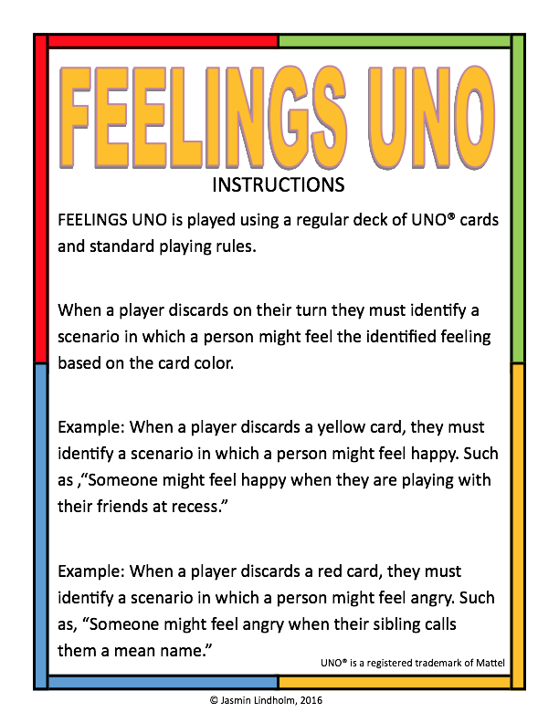

Beneath the Surface- Your Emotional Iceberg
Counselor Alicia Justice
UNIT TOPIC:  Session # | - Getting Comfortable with “You”- Identifying how you hide your emotions  - Lesson four of a six lesson unit
GRADE LEVEL(S): | 6th Grade Boys Group
ASCA STANDARDS: | A:A1 Improve Academic Self-concept: A:A1.1, A:A1.4  A:A2 Acquire Skills for Improving Learning: A:A2.1, A:A2.2, A:A2.3, A:A2.4  A:A3 Achieve School Success: A:A3.1, A:A3.2, A:A3.4, A:A3.5  PS:A1 Acquire Self-knowledge: PS:A1.1, PS:A1.4, PS:A1.5, PS:A1.6, PS:A1.7, PS:A1.8, PS:A1.9, PS:A1.11  PS:A2 Acquire Interpersonal Skills: PS:A2.1, PS:A2.2, PS:A2.4, PS:A2.6, PS:A2.7, PS:A2.8  PS:B1 Self-knowledge Application: PS:B1.4, PS:B1.5, PS:B1.6, PS:B1.7, PS:B1.8, PS:B1.9, PS:B1.11  PS:C1 Acquire Personal Safety Skills: PS:C1.4, PS:, 1.6, PS:C1.7, PS:C1.9, PS:C1.10, PS:C1.11
INDIANA STANDARDS ADDRESSED:  *If this lesson is crosswalked with other academic areas, please list here. | ISCA- Competencies  Academic Development: 6-8th  - Competency: 1.2, 1.10,  Social/Emotional Development: 6-8th  - Competency: 1.1,1.2, 1.3, 1.4, 2.1, 2.3, 2.4, 2.6, 2.7, 3.1, 3.2, 3.3, 3.4, 3.5, 3.6
ASCA MINDSETS/ BEHAVIORS | Category 1: Mindset Standards:  - M 2. Self-confidence in ability to succeed  - M 3. Sense of belonging in the school environment  - M 6. Positive attitude toward work and learning  Category 2: Behavior Standards:  - B-LS 1. Demonstrate critical-thinking skills to make informed decisions  - B-LS 2. Demonstrate creativity  - B-LS 9. Gather evidence and consider multiple perspectives to make informed decisions  - B-SMS 1. Demonstrate ability to assume responsibility  - B-SMS 2. Demonstrate self-discipline and self-control  - B-SMS 5. Demonstrate perseverance to achieve long- and short-term goals  - B-SMS 6. Demonstrate ability to overcome barriers to learning  - B-SMS 7. Demonstrate effective coping skills when faced with a problem  - B-SMS 8. Demonstrate the ability to balance school, home and community activities  - B-SMS 9. Demonstrate personal safety skills  - B-SS 1. Use effective oral and written communication skills and listening skills  - B-SS 2. Create positive and supportive relationships with other students  - B-SS 3. Create relationships with adults that support success  - B-SS 4. Demonstrate empathy  - B-SS 6. Use effective collaboration and cooperation skills  - B-SS 7. Use leadership and teamwork skills to work effectively in diverse teams  - B-SS 9. Demonstrate social maturity and behaviors appropriate to the situation and environment
SMALL GROUP OBJECTIVES: | - SWBAT: apply what they learned in the previous week about emotions and gender norms and consider how they express their emotions, by filling out the “Tip of the Iceberg” worksheet.
TIME REQUIRED | 30 minutes
MATERIALS NEEDED | - Caution Tape  - Iceberg worksheet
PROCEDURE | ESSENTIAL QUESTION: What are barriers keeping you from expressing your emotions/ how you feel?  ICEBREAKER/QUOTE OF THE DAY/HOOK- 3 minute Set up a real barrier as Ss come into the room, which hinders their ability to sit down in some way  S.C. STEPS OF LESSON: 15 MIN Debrief the Hook Activity  - Why was is difficult to find a place in the circle today?  - There was a barrier  - Aside from physical barrier, like the tape, are there other types of barriers?  - Remember last week when we discussed how gender can change the way we show how we feel? The stereotypes that young men should toughen up or man up can be a barrier to showing how you really feel.  - Show members the iceberg worksheet: Many times people only show a piece of what they are really feeling/ thinking, just like only a small portion of an iceberg is visible above water.  - “I want you to label the most common emotions you feel in a day or week, below the surface of the water line. Then I want you to think about how you show those emotions on the surface of the water.”  - “What are the barriers that keep you from showing how you really feel?”  - Have a time of discussion for the activity  - Have students show their iceberg and explain. If you they don’t feel comfortable showing their iceberg allow them to just verbally explain what they learned from the activity or Pass  5. Closure/Summary: 3 minutes  - Exit Tickets- Label one Barrier you would like to overcome this week
ASSESSMENT STRATEGIES FOR EACH SESSION | Tracking Emotional Expression From 1st Session to Final Session  - “How are Students demeanor, body language, non-verbals, seat placement, and/or verbage changing over each week?”  https://docs.google.com/document/d/1BsM22hcE5hu0AYssBhiCXdNJDZIHlnVBl9HP5SPWJrY/edit
OUTSIDE GROUP APPLICATION: | Reflect & Bring Response:  - Take note of how you eliminated one barrier to showing your emotions this week.

This is what is shows
My Emotional Iceberg
This is what I’m feeling

Emotional Expression: Behind the Mask
Counselor Alicia Justice
UNIT TOPIC:  Session # | - Getting Comfortable with “You”- Taking off your emotional masks  - Lesson five of a six lesson unit
GRADE LEVEL(S): | 6th Grade Boys Group
ASCA STANDARDS: | A:A1 Improve Academic Self-concept: A:A1.1, A:A1.4  A:A2 Acquire Skills for Improving Learning: A:A2.1, A:A2.2, A:A2.3, A:A2.4  A:A3 Achieve School Success: A:A3.1, A:A3.2, A:A3.4, A:A3.5  PS:A1 Acquire Self-knowledge: PS:A1.1, PS:A1.4, PS:A1.5, PS:A1.6, PS:A1.7, PS:A1.8, PS:A1.9, PS:A1.11  PS:A2 Acquire Interpersonal Skills: PS:A2.1, PS:A2.2, PS:A2.4, PS:A2.6, PS:A2.7, PS:A2.8  PS:B1 Self-knowledge Application: PS:B1.4, PS:B1.5, PS:B1.6, PS:B1.7, PS:B1.8, PS:B1.9, PS:B1.11  PS:C1 Acquire Personal Safety Skills: PS:C1.4, PS:, 1.6, PS:C1.7, PS:C1.9, PS:C1.10, PS:C1.11
INDIANA STANDARDS ADDRESSED:  *If this lesson is crosswalked with other academic areas, please list here. | ISCA- Competencies  Academic Development: 6-8th  - Competency: 1.2, 1.10,  Social/Emotional Development: 6-8th  - Competency: 1.1,1.2, 1.3, 1.4, 2.1, 2.3, 2.4, 2.6, 2.7, 3.1, 3.2, 3.3, 3.4, 3.5, 3.6
ASCA MINDSETS/ BEHAVIORS | Category 1: Mindset Standards:  - M 2. Self-confidence in ability to succeed  - M 3. Sense of belonging in the school environment  - M 6. Positive attitude toward work and learning  Category 2: Behavior Standards:  - B-LS 1. Demonstrate critical-thinking skills to make informed decisions  - B-LS 2. Demonstrate creativity  - B-LS 9. Gather evidence and consider multiple perspectives to make informed decisions  - B-SMS 1. Demonstrate ability to assume responsibility  - B-SMS 2. Demonstrate self-discipline and self-control  - B-SMS 5. Demonstrate perseverance to achieve long- and short-term goals  - B-SMS 6. Demonstrate ability to overcome barriers to learning  - B-SMS 7. Demonstrate effective coping skills when faced with a problem  - B-SMS 8. Demonstrate the ability to balance school, home and community activities  - B-SMS 9. Demonstrate personal safety skills  - B-SS 1. Use effective oral and written communication skills and listening skills  - B-SS 2. Create positive and supportive relationships with other students  - B-SS 3. Create relationships with adults that support success  - B-SS 4. Demonstrate empathy  - B-SS 6. Use effective collaboration and cooperation skills  - B-SS 7. Use leadership and teamwork skills to work effectively in diverse teams  - B-SS 9. Demonstrate social maturity and behaviors appropriate to the situation and environment
SMALL GROUP OBJECTIVES: | - SWBAT: incorporate what was discussed in previous week and assign gender norms to those emotions by decorating their emotional masks & Planning strategies to remove the mask.
TIME REQUIRED | 30 minutes
MATERIALS NEEDED | - Printed Masks  - Markers/Pens  - Video Ready
PROCEDURE | ESSENTIAL QUESTION:  ICEBREAKER/QUOTE OF THE DAY/HOOK- 3 minute  - Last Week we discussing how gender can influence what emotions are seen (on the surface of our iceberg) and what is unseen (below the water)  - Show Ss a mask (of any kind)- Ask them:  - “What is the purpose of a mask?”  - To hide your identity/ who you really are.  S.C. STEPS OF LESSON: Strategies to showing emotions  1. Show clip of YouTude video: 1.07-4.40  - How could you identify with this video?  - How did the girl take off her mask? What might she has felt when she walked out of the bathroom w/o her mask on?  2. “Like the students in the video, we can wear a mask in order to hide how we really feel.”  - Give Students a copy of the mask and instruct them to decorate their mask to represent what they feel internally on half & what they choose to show on the other half. (Thinking back to your emotional iceberg barriers)  - Provide time to discuss shorting their mask  - Now instruct students to label with words or pictures how they can take this mask off & show how they feel?  - What are ways we can learn to be comfortable telling other people how we really feel?  - Start with one person you trust and show them your mask  4. Closure/Summary: 3 minutes  - Exit Ticket- Give one example of how you will take off your mask this week
ASSESSMENT STRATEGIES | Tracking Emotional Expression From 1st Session to Final Session  - “How are Students demeanor, body language, non-verbals, seat placement, and/or verbage changing over each week?”  https://docs.google.com/document/d/1BsM22hcE5hu0AYssBhiCXdNJDZIHlnVBl9HP5SPWJrY/edit
OUTSIDE GROUP APPLICATION: | - THIS WEEK:  - Start with one person you trust and show them your mask.  - Ask them how they take off their mask.
CITATION(S)  References/Resources Used:  Cite copyrighted materials, but do not reproduce copyrighted materials in your lesson plan. Non-copyrighted materials must be reproduced and included in your lesson plan. | https://www.themiddleschoolcounselor.com/2014/10/borrowed-lessons-identitya-lesson-on.html?m=1 - Video  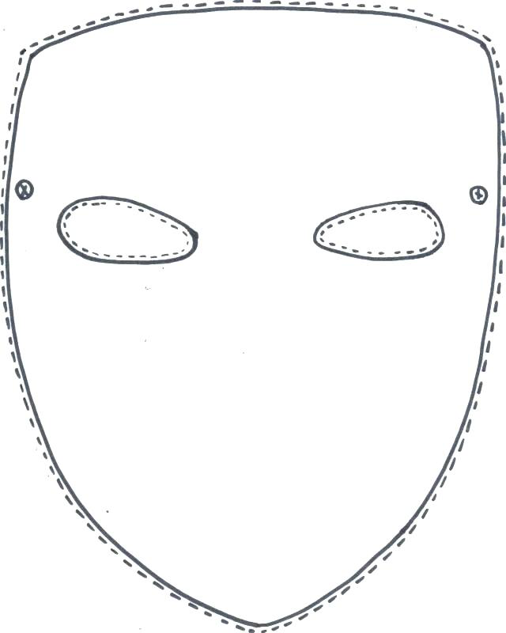

Ening Well- Closure
Counselor Alicia Justice
UNIT TOPIC:  Session # | - Getting Comfortable with “You”- Closure  - Lesson six of a six lesson unit
GRADE LEVEL(S): | 6th Grade Boys Group
ASCA STANDARDS: | A:A1 Improve Academic Self-concept: A:A1.1, A:A1.4  A:A2 Acquire Skills for Improving Learning: A:A2.1, A:A2.2, A:A2.3, A:A2.4  A:A3 Achieve School Success: A:A3.1, A:A3.2, A:A3.4, A:A3.5  PS:A1 Acquire Self-knowledge: PS:A1.1, PS:A1.4, PS:A1.5, PS:A1.6, PS:A1.7, PS:A1.8, PS:A1.9, PS:A1.11  PS:A2 Acquire Interpersonal Skills: PS:A2.1, PS:A2.2, PS:A2.4, PS:A2.6, PS:A2.7, PS:A2.8  PS:B1 Self-knowledge Application: PS:B1.4, PS:B1.5, PS:B1.6, PS:B1.7, PS:B1.8, PS:B1.9, PS:B1.11  PS:C1 Acquire Personal Safety Skills: PS:C1.4, PS:, 1.6, PS:C1.7, PS:C1.9, PS:C1.10, PS:C1.11
INDIANA STANDARDS ADDRESSED:  *If this lesson is crosswalked with other academic areas, please list here. | ISCA- Competencies  Academic Development: 6-8th  - Competency: 1.2, 1.10,  Social/Emotional Development: 6-8th  - Competency: 1.1,1.2, 1.3, 1.4, 2.1, 2.3, 2.4, 2.6, 2.7, 3.1, 3.2, 3.3, 3.4, 3.5, 3.6
ASCA MINDSETS/ BEHAVIORS | Category 1: Mindset Standards:  - M 2. Self-confidence in ability to succeed  - M 3. Sense of belonging in the school environment  - M 6. Positive attitude toward work and learning  Category 2: Behavior Standards:  - B-LS 1. Demonstrate critical-thinking skills to make informed decisions  - B-LS 2. Demonstrate creativity  - B-LS 9. Gather evidence and consider multiple perspectives to make informed decisions  - B-SMS 1. Demonstrate ability to assume responsibility  - B-SMS 2. Demonstrate self-discipline and self-control  - B-SMS 5. Demonstrate perseverance to achieve long- and short-term goals  - B-SMS 6. Demonstrate ability to overcome barriers to learning  - B-SMS 7. Demonstrate effective coping skills when faced with a problem  - B-SMS 8. Demonstrate the ability to balance school, home and community activities  - B-SMS 9. Demonstrate personal safety skills  - B-SS 1. Use effective oral and written communication skills and listening skills  - B-SS 2. Create positive and supportive relationships with other students  - B-SS 3. Create relationships with adults that support success  - B-SS 4. Demonstrate empathy  - B-SS 6. Use effective collaboration and cooperation skills  - B-SS 7. Use leadership and teamwork skills to work effectively in diverse teams  - B-SS 9. Demonstrate social maturity and behaviors appropriate to the situation and environment
SMALL GROUP OBJECTIVES: | - SWBAT: incorporate what they have learned about expressing their emotions and practice with each other through an accolades activity.
TIME REQUIRED | 30 minutes
MATERIALS NEEDED | - M&Ms & Skittles  - Certificate
PROCEDURE | ESSENTIAL QUESTION:  ICEBREAKER/QUOTE OF THE DAY/HOOK- Emotional Controller 3 minute  - Show a Remote Controller of some kind  - Ask Ss what the item is and its purpose  - Similar to this remote the way we choose to show or not show our emotions in like a controller.  S.C. STEPS OF LESSON: 15-18 min  - Pass out controller pictures (7min) & give Ss 2 minutes to label their controllers with some strategies with discussed last week and some emotions  - Example:  - The Skip button could be labeled “Play basketball” as a way to show how to respond more positively to anger  - The Play button could be labeled: “Use I statement” to show how to communicate their feelings  - You can take this controler home with you & put in somewhere you often look, as a helpful reminder of way to show your emotions  - Accolades (10 minutes):  - Ask group members to close their eyes & take a moment to consider how they & others in the group have changed in 6 weeks  - Give members a pack of M&M or Skittles  - Questions  - Brown/ Purple (is skittles- Choose a member to share something you learned from  - Green: Choose a member to share a way you value him  - Yellow: Choose a member that made you feel comfortable & welcomed in the group & share why  - Orange: Choose a member who shared something that impressed you and why.  - Red: Choose a member and tell him at least one way you have seen him change.  - Blue: You choose what to say to someone in the group  5. Closure/Summary: 2 minutes - Post Test  - https://docs.google.com/forms/d/1lU5nx79n3CIMIui1SPHNzItM4BULaMMnrGMNpkZYmYc/edit
ASSESSMENT STRATEGIES | Tracking Emotional Expression From 1st Session to Final Session  - “How are Students demeanor, body language, non-verbals, seat placement, and/or verbage changing over each week?”  https://docs.google.com/document/d/1BsM22hcE5hu0AYssBhiCXdNJDZIHlnVBl9HP5SPWJrY/edit
OUTSIDE GROUP APPLICATION: | Reflect & Bring Response:  - Follow up with Ms. Alicia at the end of the semester to check in.

Resources:
Progress Note
Name of Group Member: ________________________________________________________Grade: _____________
Session # 1 Date: __________________________
Participation: 1 2 3 4 5 Attention: 1 2 3 4 5
Behavior: 1 2 3 4 5 Mood: ________________________________
Notes: ____________________________________________________________________________________________
__________________________________________________________________________________________________
__________________________________________________________________________________________________
Session # 2 Date: __________________________
Participation: 1 2 3 4 5 Attention: 1 2 3 4 5
Behavior: 1 2 3 4 5 Mood: ________________________________
Notes: ____________________________________________________________________________________________
__________________________________________________________________________________________________
__________________________________________________________________________________________________
Session # 3 Date: __________________________
Participation: 1 2 3 4 5 Attention: 1 2 3 4 5
Behavior: 1 2 3 4 5 Mood: ________________________________
Notes: ____________________________________________________________________________________________
__________________________________________________________________________________________________
__________________________________________________________________________________________________
Session # 4 Date: __________________________
Participation: 1 2 3 4 5 Attention: 1 2 3 4 5
Behavior: 1 2 3 4 5 Mood: ________________________________
Notes: ____________________________________________________________________________________________
__________________________________________________________________________________________________
__________________________________________________________________________________________________
Name of Group Member: _______________________________________________________Grade: ________________
Session # 5 Date: __________________________
Participation: 1 2 3 4 5 Attention: 1 2 3 4 5
Behavior: 1 2 3 4 5 Mood: ________________________________
Notes: ____________________________________________________________________________________________
__________________________________________________________________________________________________
__________________________________________________________________________________________________
Session # 6 Date: __________________________
Participation: 1 2 3 4 5 Attention: 1 2 3 4 5
Behavior: 1 2 3 4 5 Mood: ________________________________
Notes: ____________________________________________________________________________________________
__________________________________________________________________________________________________
__________________________________________________________________________________________________
Session # 7 Date: __________________________
Participation: 1 2 3 4 5 Attention: 1 2 3 4 5
Behavior: 1 2 3 4 5 Mood: ________________________________
Notes: ____________________________________________________________________________________________
__________________________________________________________________________________________________
__________________________________________________________________________________________________
Parent Contact Made: _____ yes _____ no Date (s): ___________________________________________________
Parent Contact Notes: ________________________________________________________________________________
__________________________________________________________________________________________________
Wrap – up Notes : ___________________________________________________________________________________
__________________________________________________________________________________________________
__________________________________________________________________________________________________

Resourced CONT.

Pre/Post Test
https://docs.google.com/forms/d/1lU5nx79n3CIMIui1SPHNzItM4BULaMMnrGMNpkZYmYc/edit

Resourced CONT.

Exit Tickets:

EXIT
EXIT
Name:_________________ Date:______________
How might you apply today’s topic outside of group?
____________________________________________
____________________________________________
____________________________________________

What might make your experience better in group? Or What made your experience good today?
____________________________________________________________________________________________________________________________________

TICKET

EXIT
EXIT
Name:_________________ Date:______________
How might you apply today’s topic outside of group?
____________________________________________
____________________________________________
____________________________________________

What might make your experience better in group? Or What made your experience good today?
____________________________________________________________________________________________________________________________________

TICKET

Resourced CONT.

Certificate of Completion:

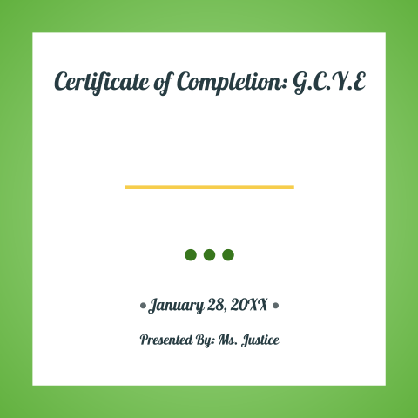

FLYER & Parent/Guardian Permission:

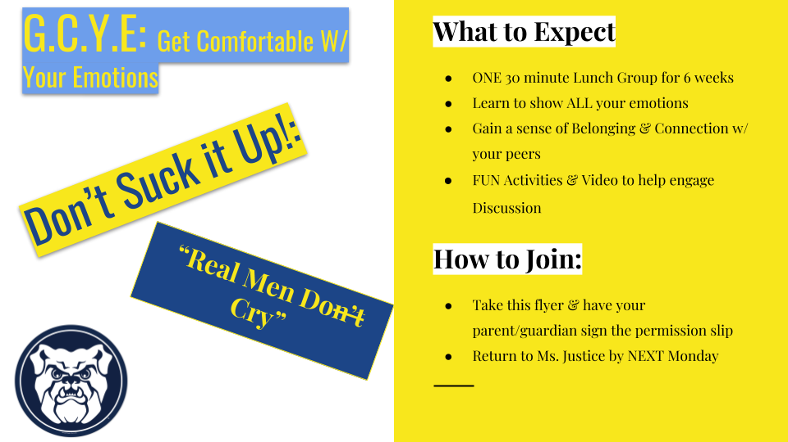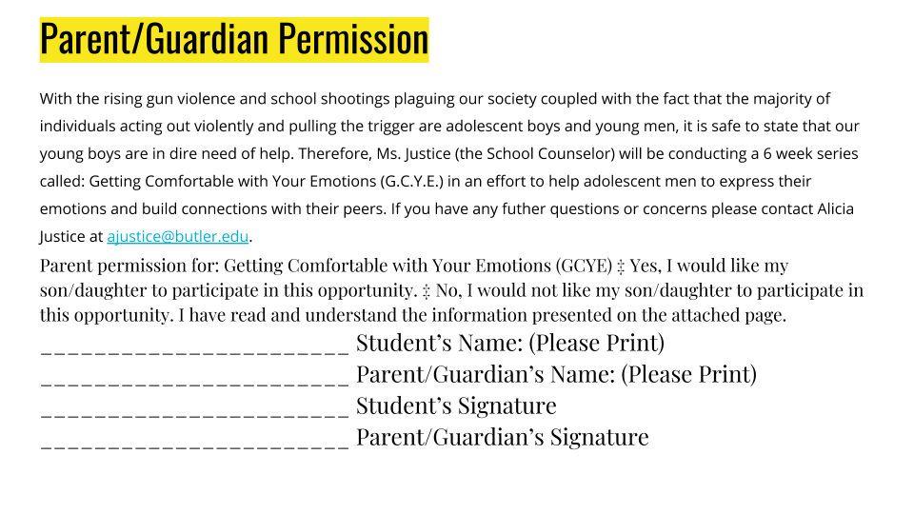

References:
Black, I. B., 2018. The boys are not all right. The New York Times. Retrieved from:
https://www.nytimes.com/2018/02/21/opinion/boys-violence-shootings-guns.html
Cyhanenko, N., Madrigal, L., To, H., & Yu, R. 2007. Conflict avoidance & resolution series: An anger management Program: CARS. California State University, Sacramento, CA. Retrieved from: https://moodle.butler.edu/pluginfile.php/1256179/mod_resource/content/0/CARS%20CURRICULUM.pdf
Way, N. 2014. The friendship crisis: Why are boys so lonely and violent? The Washington Post. Retrieved from: https://www.washingtonpost.com/posteverything/wp/2014/06/13/boys-are-bad-at-making-friends-and-its-at-the-heart-of-their-violent-behavior/?utm_term=.d15928567bc7

