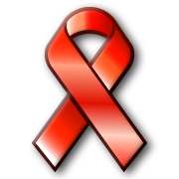
Red Ribbon Week!

October 9-13, 2017
Monday- Wear RED Day!!
Tuesday- Sports Superstars make healthy choices! Wear a jersey or sweatshirt supporting your favorite team!
Wednesday- The Future’s So Bright-I gotta wear shades!
Thursday- We can’t hide our healthy choices! Wear camouflage or brown/green today!
Friday- Freaky Friday!!
We will celebrate our healthy choices with morning announcements, prizes and other activities.

