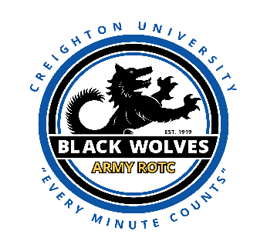
I invite you to apply to the Army ROTC Scholarship. You could earn a full tuition and fees scholarship! Creighton University gives all ROTC Scholarship cadets free room and board. On top of that the Army will also give you $1200 per year for books and pays you a monthly spending stipend of $420 per month!

If you earn a 4 - year scholarship from Army ROTC at Creighton University:
Tuition 100% paid
Fees 100% paid
Books paid ($1200 per year maximum)
Room and Board 100% paid by Creighton University
= zero out of pocket expense.

In fact, you will pocket roughly $15,000 that you earn from the monthly spending stipend over your 4 years.

Army ROTC at Creighton University is a phenomenal opportunity that provides the ability to attend one the premier leadership development programs in the world. No matter what you plan to study in college, Army ROTC can easily fit into your schedule.
Starting college can be daunting; new environment, different personalities and potentially your first opportunity to develop your own daily routine. Staying busy and having an instant group of peers who are working their way through similar challenges creates more stability in your routine and allows for a wider support structure.
The Black Wolves are committed to successful completion of your college aspirations. We teach invaluable skills in and out of the classroom; self-reliability, time management, stress management and simple lessons that will relate to the world that you will soon be working in. Not to mention an in-house physical fitness plan that will assist in the fight against the “Freshmen 15”
The great thing about being a part of Army ROTC is that you can earn full tuition scholarships and receive free room and board on behalf of Creighton University once you are on scholarship.
To explore this opportunity please contact me at toddfrerichs@creighton.edu I will answer any questions you may have about the program. We can communicate through email or Zoom to ensure you have all your questions answered. If you know you want to apply for the scholarship now, simply respond via email asking for the application instructions and I will send those right away.
There are over 1,700 colleges that have Army ROTC on campus. For a complete list of all ROTC colleges look over this link: https://www.goarmy.com/rotc.html
Todd A. Frerichs
Army ROTC Scholarship Coordinator
Creighton University/University of Nebraska-Omaha/Bellevue University
Office: 402-280-1154
Facebook: https://www.facebook.com/Creighton-University-Army-ROTC-Black-Wolves-265973610084800/

